**Once you received email or notification that DASD added proceed to check out.**

**SSH to the server under and source environment to +ASM (+ASM1 if RAC)**

**Verify that new disks added with PROVISIONED status (See example below)**

xhedwdbm2ap.aetna.com (oracle) +ASM1::/home/oracle

+ASM1> sqlplus / as sysdba

SQL*Plus: Release 19.0.0.0.0 - Production on Wed Nov 13 06:57:39 2024

Version 19.23.0.0.0

Copyright (c) 1982, 2023, Oracle. All rights reserved.

Connected to:

Oracle Database 19c Enterprise Edition Release 19.0.0.0.0 - Production

Version 19.23.0.0.0

[SYS@:+ASM1] SQL> @showasm

MOUNT_STATUS HEADER_STATUS OS_MB TOTAL_MB FREE_MB SECTOR_SIZE LOGICAL_SECTOR_SIZE Name Label Path

------------ -------------- ---------- ---------- ---------- ----------- ------------------- ------------------ ------------ ---------

CACHED MEMBER 3276799 3276796 361204 512 512 DATA1_0017 ASMD1018 /dev/ora8

CACHED MEMBER 3276799 3276796 361224 512 512 DATA1_0018 ASMD1019 /dev/ora9

CACHED MEMBER 3276799 3276796 361316 512 512 DATA1_0019 ASMD1020 /dev/ora0

CACHED MEMBER 3276799 3276796 361208 512 512 DATA1_0020 ASMD1021 /dev/ora1

CACHED MEMBER 3276799 3276796 361172 512 512 DATA1_0021 ASMD1022 /dev/ora2

CACHED MEMBER 3276799 3276796 361164 512 512 DATA1_0022 ASMD1023 /dev/ora3

CACHED MEMBER 3276799 3276796 361220 512 512 DATA1_0023 ASMD1024 /dev/ora4

CACHED MEMBER 3276799 3276796 361280 512 512 DATA1_0024 ASMD1025 /dev/ora5

CLOSED PROVISIONED 3276800 0 0 512 512 /dev/ora6

CLOSED PROVISIONED 3276800 0 0 512 512 /dev/ora7

CLOSED PROVISIONED 3276800 0 0 512 512 /dev/ora8

CLOSED PROVISIONED 3276800 0 0 512 512 /dev/ora9

**Verify appropriate permissions on OS level**

**On “RHEL7” VM’s the asm disk permissions should look as the following or at least new disks should have the same permissions as other existing disks**

+ASM> ls -l /dev/oracleasm/disks/*

brw-rw---- 1 oracle dba  8, 240 Mar 18 08:18 /dev/oracleasm/disks/VOLDAT01

brw-rw---- 1 oracle dba  8,  48 Mar 18 08:18 /dev/oracleasm/disks/VOLDAT02

brw-rw---- 1 oracle dba 65,   0 Mar 18 08:17 /dev/oracleasm/disks/VOLDAT03

brw-rw---- 1 oracle dba  8,  64 Mar 18 08:17 /dev/oracleasm/disks/VOLDAT04

brw-rw---- 1 oracle dba 65,  16 Mar 18 08:17 /dev/oracleasm/disks/VOLDAT05

brw-rw---- 1 oracle dba  8,  80 Mar 18 08:17 /dev/oracleasm/disks/VOLDAT06

brw-rw---- 1 oracle dba 65,  32 Mar 18 08:18 /dev/oracleasm/disks/VOLDAT07

brw-rw---- 1 oracle dba  8,  96 Mar 18 08:17 /dev/oracleasm/disks/VOLDAT08

brw-rw---- 1 oracle dba  8, 176 Mar 18 08:16 /dev/oracleasm/disks/VOLFLSH1

brw-rw---- 1 oracle dba  8, 192 Mar 18 07:31 /dev/oracleasm/disks/VOLFLSH2

brw-rw---- 1 oracle dba  8, 208 Mar 18 08:17 /dev/oracleasm/disks/VOLFLSH3

brw-rw---- 1 oracle dba  8, 224 Mar 18 08:18 /dev/oracleasm/disks/VOLFLSH4

brw-rw---- 1 oracle dba  8, 112 Mar 18 08:18 /dev/oracleasm/disks/VOLREDO1

brw-rw---- 1 oracle dba  8, 128 Mar 18 08:18 /dev/oracleasm/disks/VOLREDO2

brw-rw---- 1 oracle dba  8, 144 Mar 18 08:18 /dev/oracleasm/disks/VOLREDO3

brw-rw---- 1 oracle dba  8, 160 Mar 18 08:18 /dev/oracleasm/disks/VOLREDO4

**On “RHEL8” VM’s the asm disk permissions should look as the following or at least new disks should have the same permissions as other existing disks**

PTCHTST0> ls -l /dev/oracleasm/disks/*

brw-rw-r-- 1 grid asmadmin  8, 208 Mar 18 08:17 /dev/oracleasm/disks/ASMA0001

brw-rw-r-- 1 grid asmadmin  8,  64 Mar 18 08:17 /dev/oracleasm/disks/ASMD0001

brw-rw-r-- 1 grid asmadmin  8, 224 Mar 18 08:17 /dev/oracleasm/disks/ASMD0002

brw-rw-r-- 1 grid asmadmin  8,  80 Mar 18 08:16 /dev/oracleasm/disks/ASMD0003

brw-rw-r-- 1 grid asmadmin  8, 240 Mar 18 08:16 /dev/oracleasm/disks/ASMD0004

brw-rw-r-- 1 grid asmadmin  8,  96 Mar 18 08:13 /dev/oracleasm/disks/ASMD0005

brw-rw-r-- 1 grid asmadmin 65,   0 Mar 18 08:13 /dev/oracleasm/disks/ASMD0006

brw-rw-r-- 1 grid asmadmin  8, 112 Mar 18 08:16 /dev/oracleasm/disks/ASMD0007

brw-rw-r-- 1 grid asmadmin 65,  16 Mar 18 08:16 /dev/oracleasm/disks/ASMD0008

brw-rw-r-- 1 grid asmadmin  8, 160 Mar 18 08:17 /dev/oracleasm/disks/ASMFA001

brw-rw-r-- 1 grid asmadmin  8, 128 Mar 18 08:16 /dev/oracleasm/disks/ASMR1001

brw-rw-r-- 1 grid asmadmin  8, 144 Mar 18 08:17 /dev/oracleasm/disks/ASMR1002

brw-rw-r-- 1 grid asmadmin  8, 176 Mar 18 08:16 /dev/oracleasm/disks/ASMR2001

brw-rw-r-- 1 grid asmadmin  8, 192 Mar 18 08:17 /dev/oracleasm/disks/ASMR2002

If this PROD schedule change ticket for ASM rebalance. It could impact Database Performance while rebalance in progress!!!

Specify appropriate server name in Search Target Name field (top right)

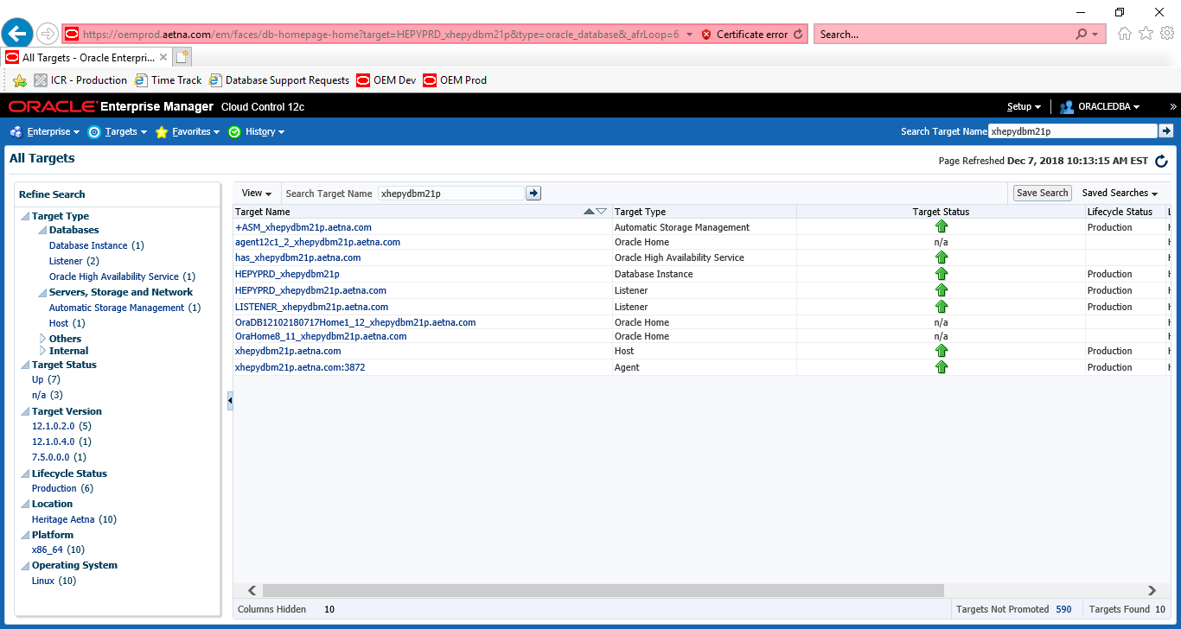

Click on appropriate +ASM instance

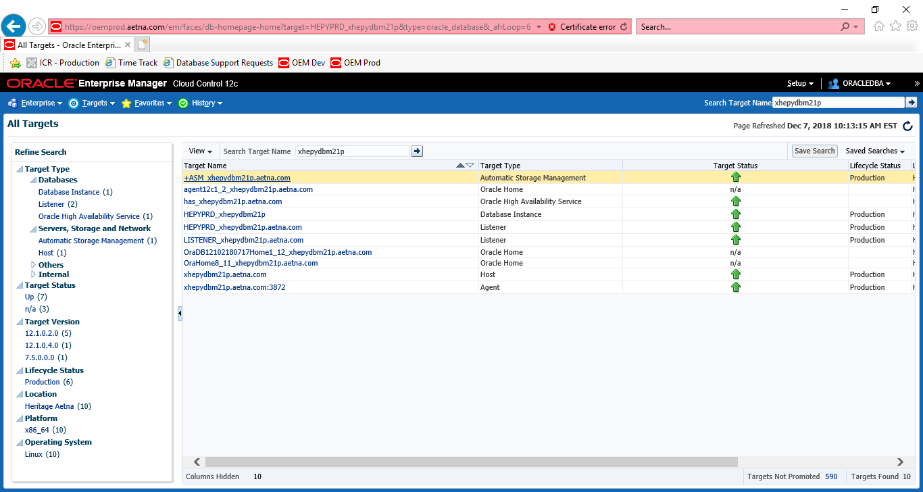

Click on Disk Groups under Automatic Storage Management.

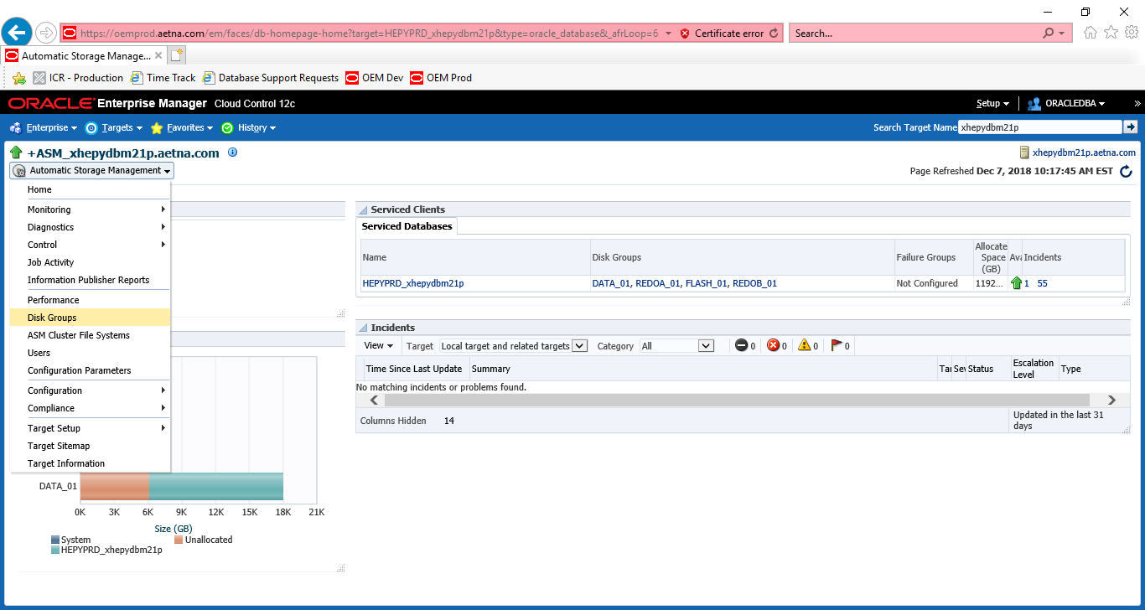

SYS

SYSASM

SYSASM

**!!! PY CONFIG box and DW CONFIG as well as new RAC servers, maybe new RHEL8 password is different:**  ASMPWD#1

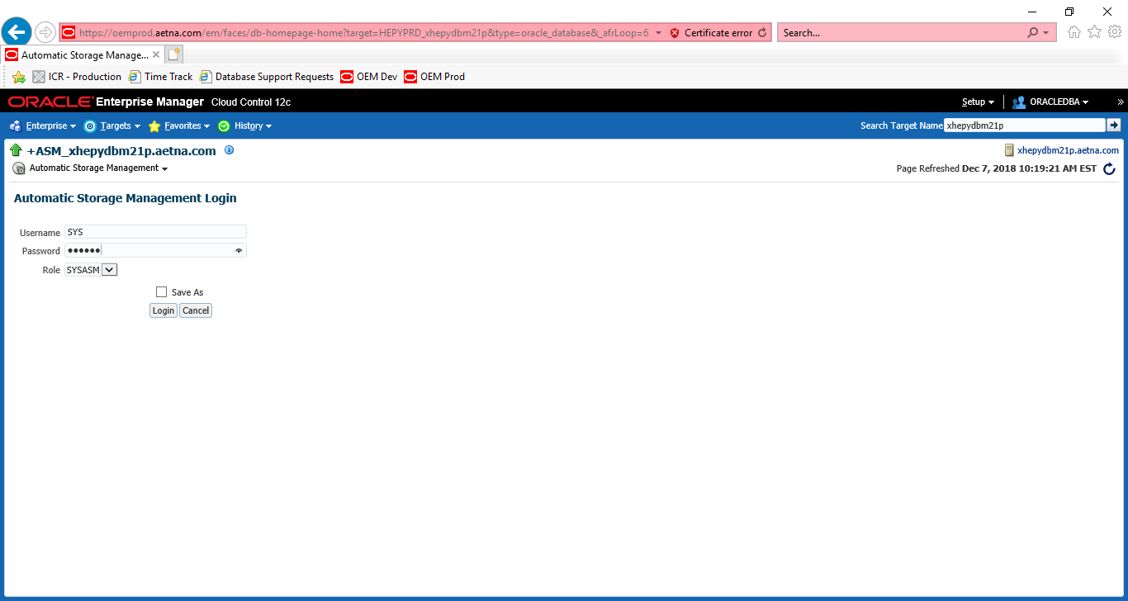

If you get error below

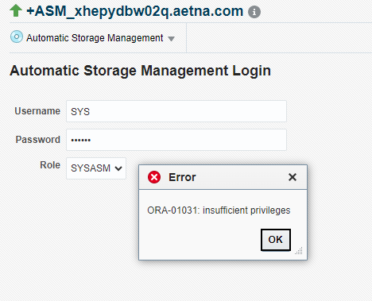

**Login to appropriate server**

sqlplus / as sysasm

GRANT sysasm to sys

/

Click on appropriate Disk group. In our example would be DATA_01

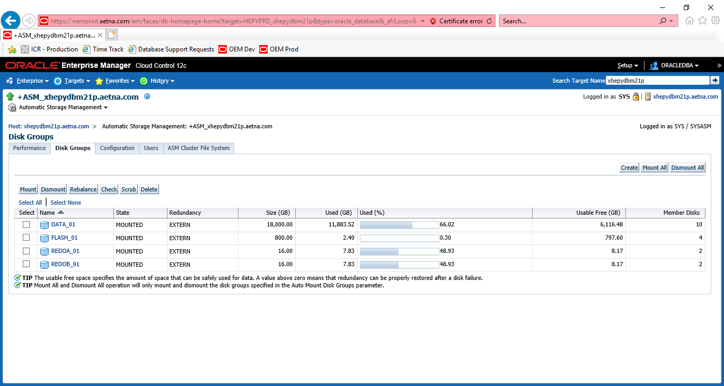

Click on Add button middle right corner

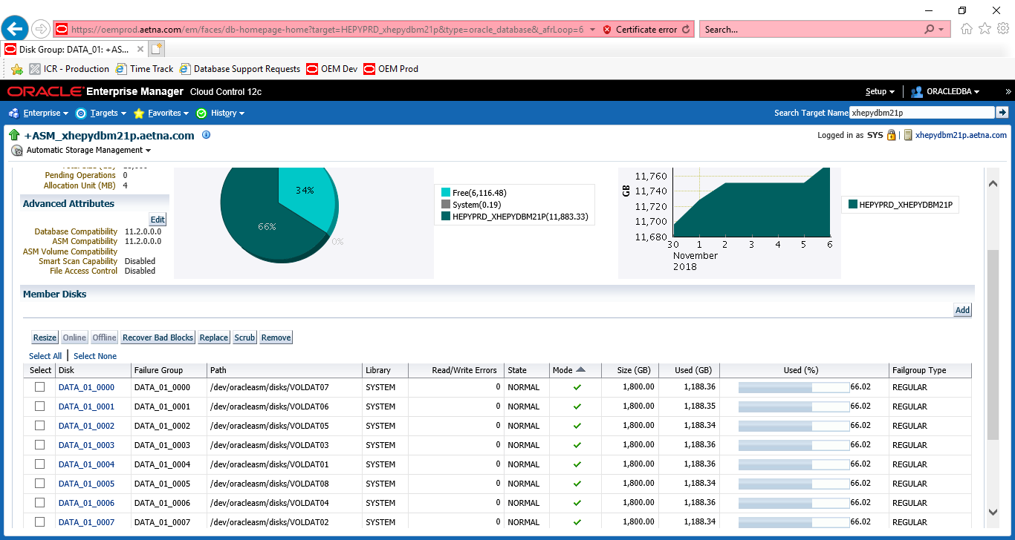

Do one Disk at the time (if more than one to be added). Put power 500. Click ok when ready.

Or do 0 balance first one and do rebalance (500) with other one.

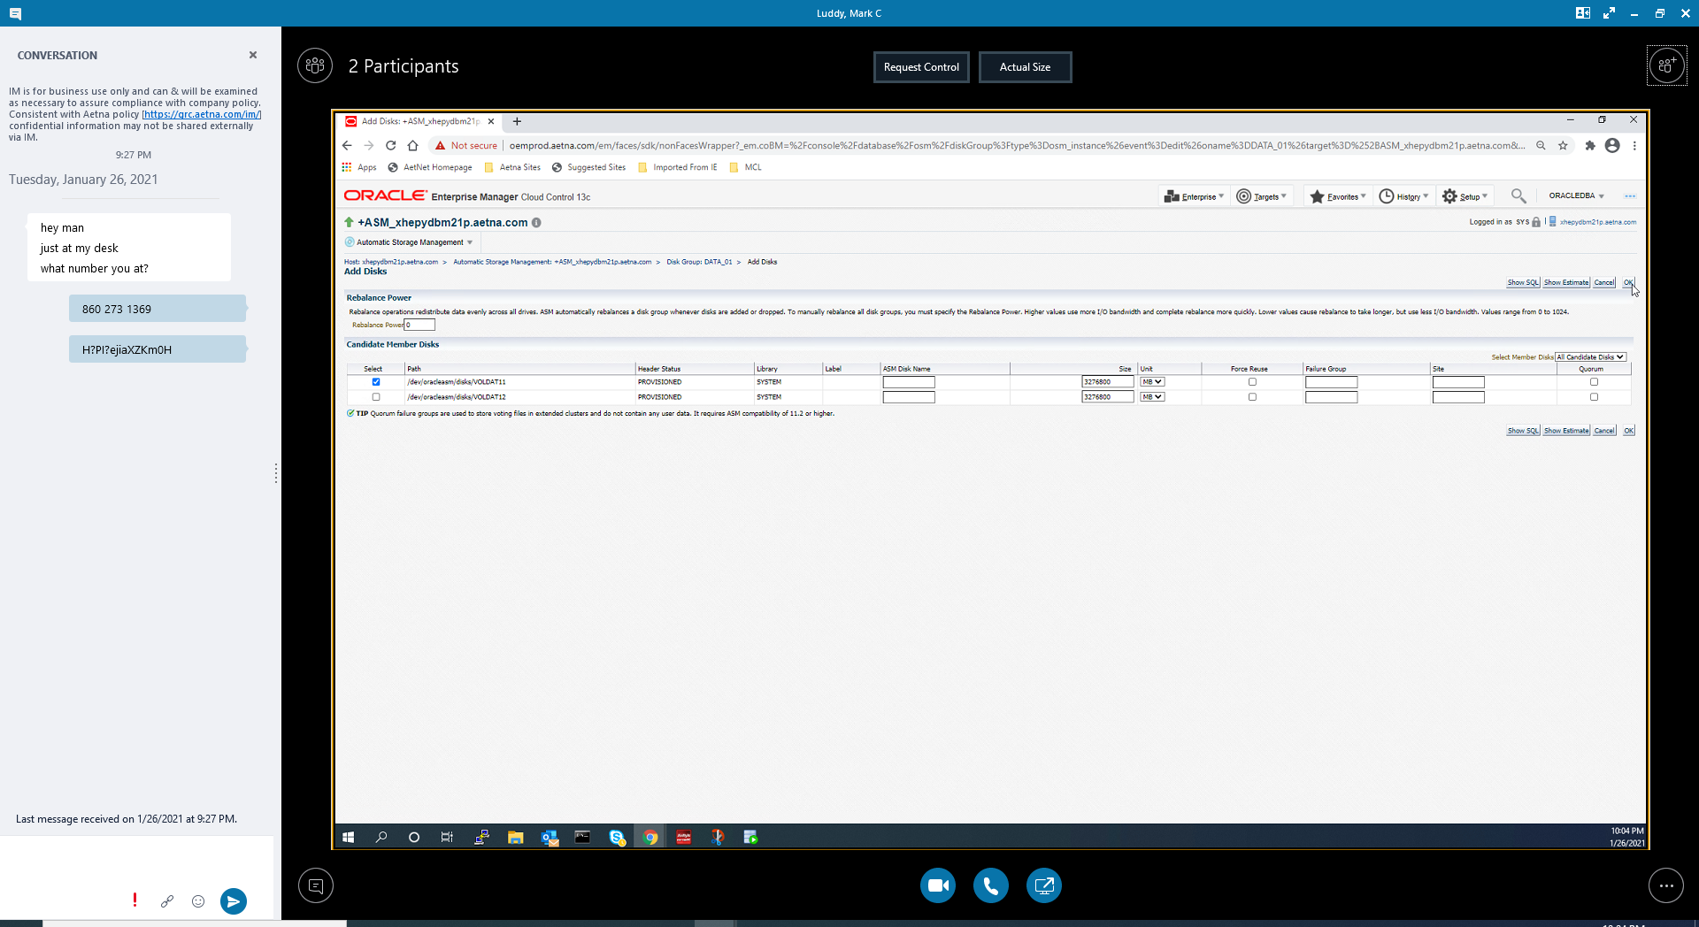

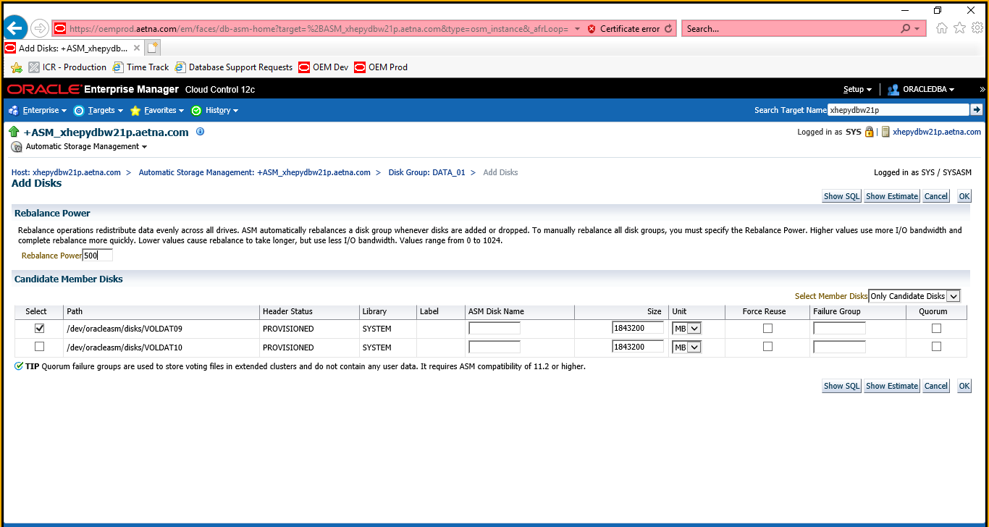

This may take some time. To monitor login to appropriate server.

+ASM>

cd /orahome/u01/app/oracle/local/sql

sqlplus / as sysdba

@asm_rebalance_progress.sql

Keep hitting following key “/” to monitor progress.

First part it will be doing REBALANCE. Keep eye on SOFAR number it will be increasing gradually until it reaches EST_WORK number.

After that it will start doing COMPACT. Keep eye on SOFAR number it will be increasing gradually. It may or may not reaches SOFAR number above (REBALANCE line) but keep hitting “/” key until you get no rows return message. This will be indication that everything completed for this particular DISK. Go back to OEM if you need to add another disk and repeat process.

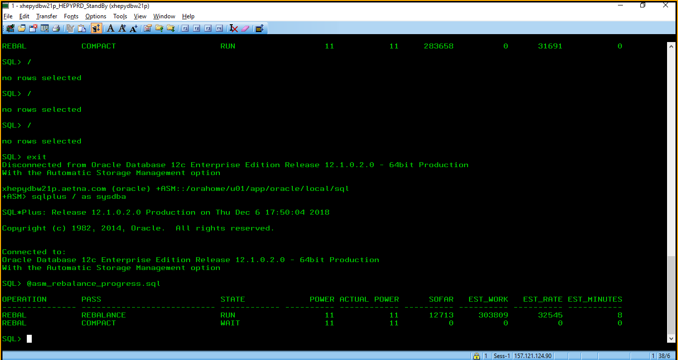

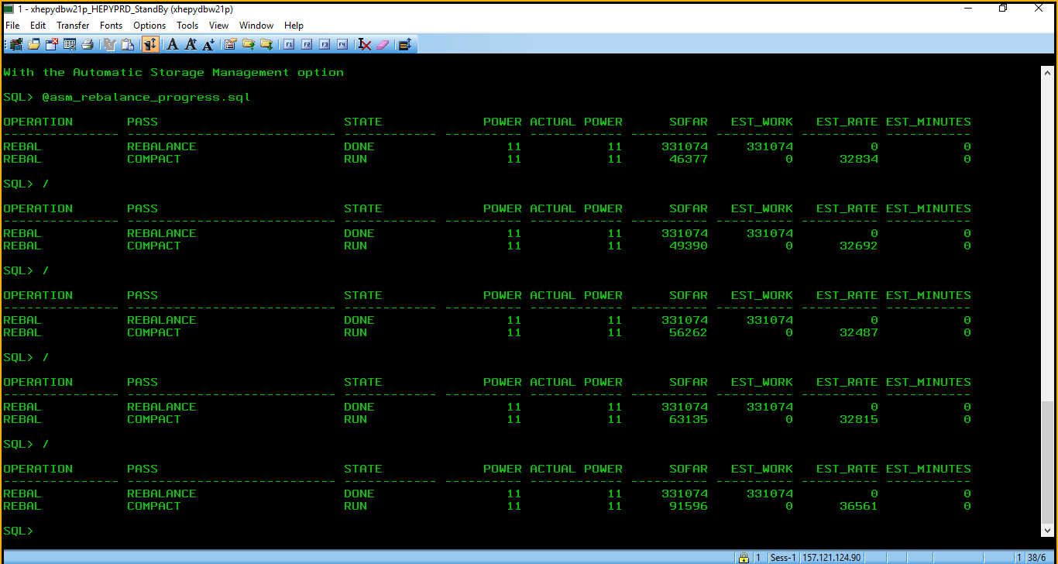

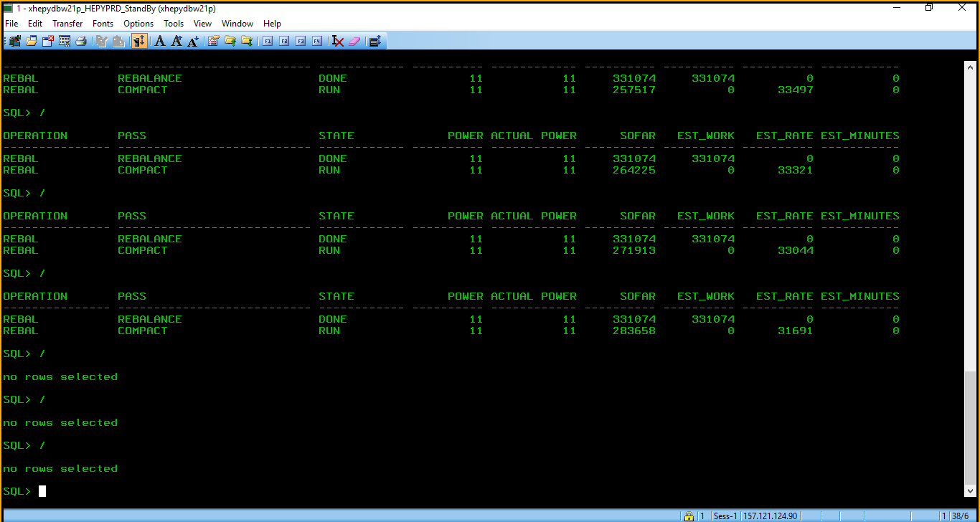

no rows selected (compact is done)

Last thing just to make sure. Run following script to see space allocation.

sqlplus / as sysdba

@showasm

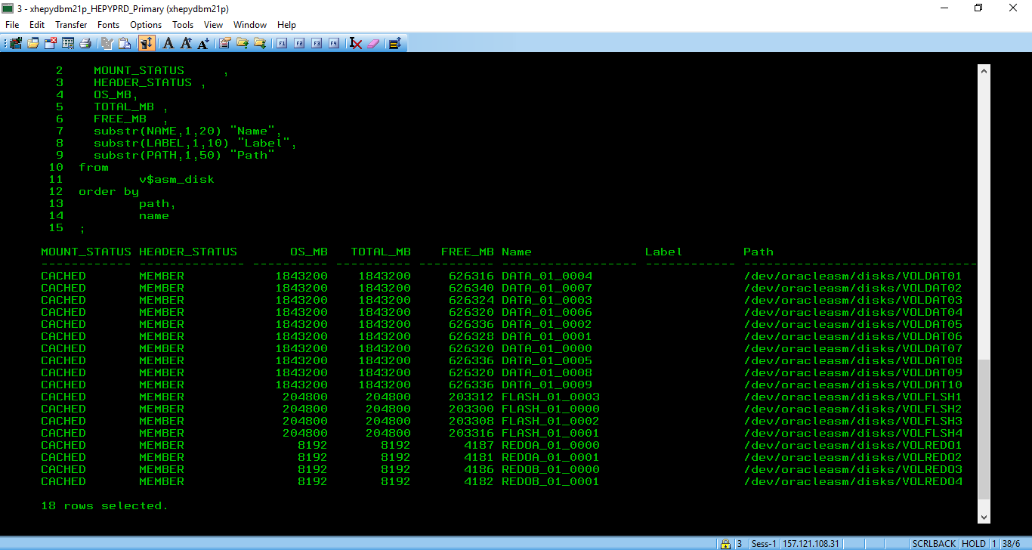

You can also run following query. Example below from DBArtisan

select

MOUNT_STATUS ,

HEADER_STATUS ,

OS_MB,

TOTAL_MB ,

FREE_MB ,

substr(NAME,1,20) "Name",

substr(LABEL,1,10) "Label",

substr(PATH,1,50) "Path"

from

v$asm_disk

order by

path,

name

;

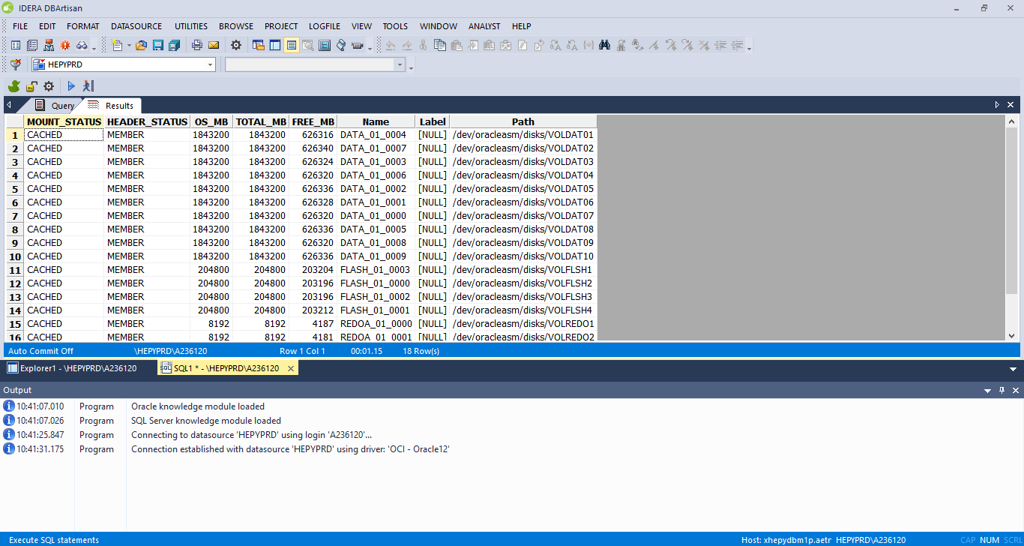

That command is the equivalent to using the below command within ASM    ☺

+ASM

sqlplus / as sysasm

**ALTER** DISKGROUP IND_01 **ADD** DISK '/dev/oracleasm/disks/VOLIND09' **SIZE** 204800 M REBALANCE POWER 500;

So now we can add datafiles to the tablespace or stretch existing for example from 16 GB to 24 GB or from 24 GB to 31 GB